Digitech GNX1
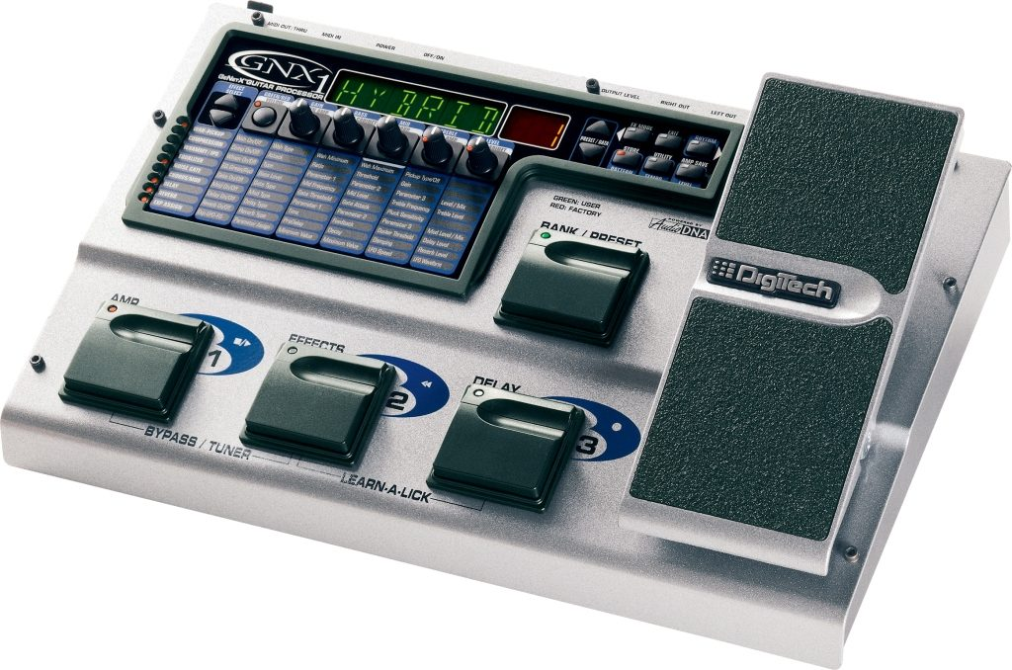
MIDI System Exclusive
by
Gary Barnes
Version 1.2

Copyright © 2025 Gary Barnes. All rights reserved.

Table of Contents
Introduction 4
Message Format 5
Packed Data 6
Number Format 7
Banks and Patches 7
Command Codes 8
Code 01: Device Enquiry 9
Code 02: Power On Announcement 10
Code 05: Status Request 10
Code 06: Response to Code 05 Status Request 11
Code 07: Request Amp & Cab Data 12
Code 08: Response to Code 07 Request Amp and Cab Data 12
Code 09: Request User Bank Names 14
Code 0A: Response to Code 09 Request User Bank Names 14
Code 0B: Request User Amp and Cab Patches 16
Code 0C: Unknown 16
Code 0D: Unknown 16
Code 0E: Unknown 17
Code 0F: Response to Code 0B Request Amp and Cab Patches 17
Code 10: Data Block Request Terminator 18
Code 11: Unknown 18
Code 12: Request Patch Names 18
Code 13: Response to Code 12 Request Patch Names 19
Code 14: Unknown 19
Code 15: Unknown 20
Code 20: Request Patch Name 20
Code 21: Response to Code 20 Request Patch Name 21
Code 22: End of Data Dump 22
Code 23: Unknown 22
Code 24: Edit Buffer Patch Data 22
Code 25: No Response 24
Code 26: LFO and Expression Pedals 24
Code 27: Unknown 26
Code 28: Sync Data 26
Code 29: Send Amp/Cab Data 27
Code 2A: Amp or Cabinet Data Block 27
Code 2B: Unknown 28
Code 2C: Parameter Change 28
Code 2C Sections 29
Section 01 (Pickup Simulator) Parameters 29
Section 02 (Wah) Parameters 29
Section 03 (Compressor) Parameters 30
Section 04 (Whammy/IPS) Parameters 30
Type 00: Whammy 30
Type 01: IPS 31
Type 02: Detune 31
Type 03: Pitch 31
Section 05 (Warp) Parameters 31
Section 06 (Green Amp) Parameters 32
Section 07 (Green Cabinet) Parameters 32
Section 08 (Red Amp) Parameters 33
Section 09 (Red Cabinet) Parameters 33
Section 0A (Noise Gate) Parameters 34
Type 00: Silencer 34
Type 01: Pluck 34
Section 0B (Chorus/Mod) Parameters 35
Type 00: Chorus 35
Type 01: Flanger 35
Type 02: Phaser 35
Type 03: Triggered Flanger 36
Type 04: Triggered Phaser 36
Type 05: Tremelo 36
Type 06: Panner 36
Type 07: Vibrato 37
Type 08: Rotary Speaker 37
Type 09: Auto Yah 37
Type 0A: YaYa 38
Type 0B: Synthtalk 38
Type 0C: Envelope 38
Type 0D: Detune 38
Type 0E: Pitch 39
Section 0C (Delay) Parameters 39
Section 0D (Reverb) Parameters 40
Section 0E Pedal Parameters 40
Section 8A (LFO 1) Parameters 40
Section 8B (LFO 2) Parameters 40
Code 2D: Patch Change 41
Code 2E: Save Patch or Amp/Cab With Name 41
Code 76: Keep Alive 42
Code 7E: Acknowledge 42
Code 7F: Error 43
GNX1 / GENEdit Startup Dialog 44

Introduction
The Digitech GNX1 is a powerful vintage guitar effects processor which shipped with the GENEdit software package for editing from a Windows machine. I wanted to create a Linux of that software, and so I contacted Digitech for documentation on the MIDI System Exclusive messages which the software uses to communicate with the device. Unfortunately, Digitech had nothing they could give me, so I set about decoding the transmitted messages.
This document describes what I have discovered to date. It may not be complete but there is enough for me to build my editing software, built in the Python programming language using the Qt framework, which should mean that it is cross-platform.
My software is called GNXEdit and is available on GitHub as an open source project (although currently in development) at https://github.com/gary-1959/GNXEdit.

Message Format
There are many resources on the internet which detail the MIDI System Exclusive format, so I will skip that here and concentrate on the message contents applicable to the GNX1.
The general format is as follows (number is hexadecimal unless stated otherwise):
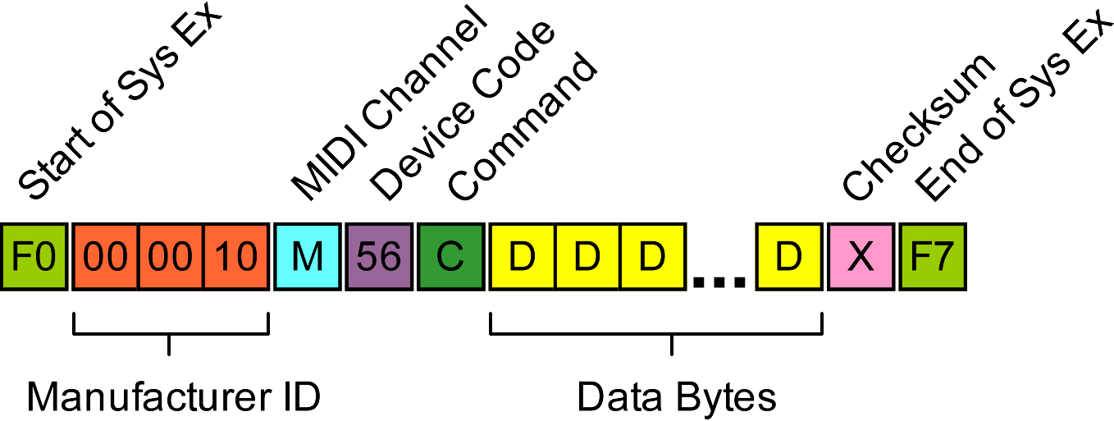
Start of Sys EX | Always 0xF0
Manufacturer ID | Three bytes 0x00, 0x00, 0x10 which is listed as the ID for DOD Electronics Corp with the Association of Musical Electronics Industry (AMIE)
MIDI Channel | 0x00 to 0x0F corresponding to MIDI channels 1 to 15 (decimal), or the broadcast code 0x7E used when probing the MIDI connection for compatible devices on any channel.
Device Code | Manufacturer’s unique identifier for the GNX1. Always 0x56.
Command | A code describing the contents of the message. This is detailed in this document.
Data Bytes | A variable number of data bytes, usually in a packed format which is detailed in this document
Checksum | Standard System Exclusive checksum, which is an XOR sum of all the preceding bytes excluding the 0xF0 start of message code
End of Sys Ex | Always 0xF0

Because MIDI is quite a slow format, the GNX1 encodes numbers according to their size to minimise message lengths (see below). Therefore, when encoding a complete message the number values are first encoded then the complete data package is packed.

Packed Data
The MIDI protocol defines bytes with the most significant bit (MSB) set as commands. This means that byte values higher or equal to 0x80 (128 decimal) are a command of some description. This means that data bytes transmitted within a System Exclusive message are limited to the value 0x7F.
To overcome this the GNX1 uses a method of data packing consisting of a single byte containing the most significant bits of the following 7 bytes. Note that the last packet transmitted can be truncated to less than 7 bytes (no padding is used).
The first byte is constructed as follows:
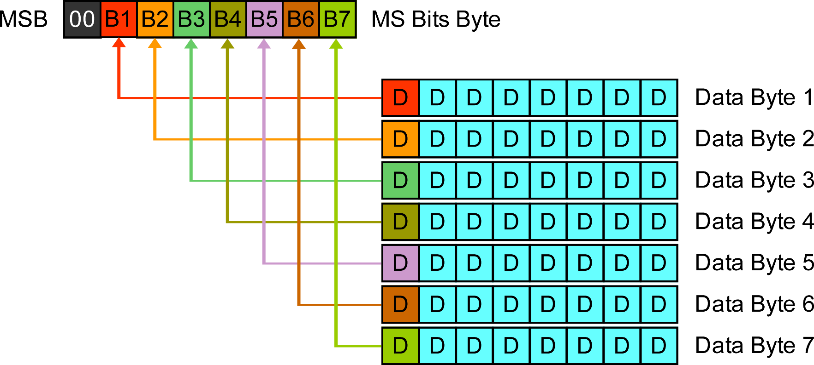
Example:
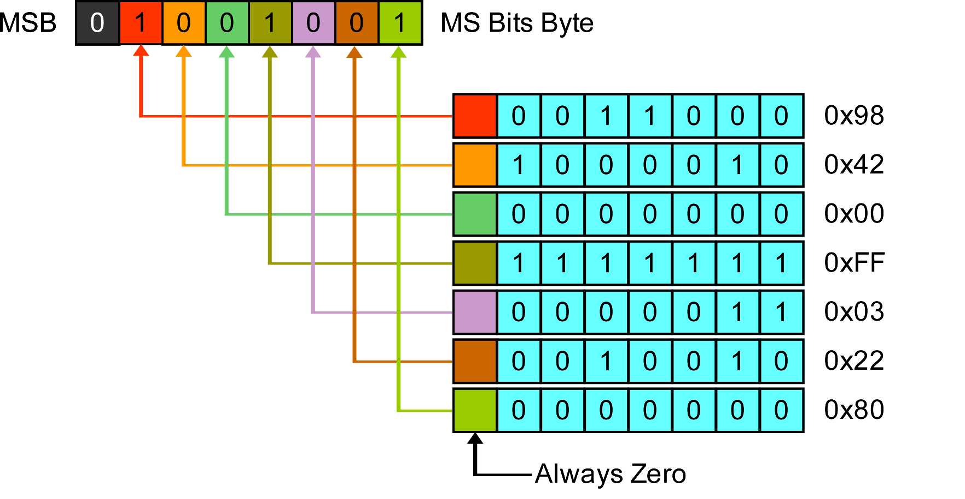

In this example the byte sequence:
 | 0x98 | 0x42 | 0x00 | 0xFF | 0x03 | 0x22 | 0x80

becomes:
0x49 | 0x18 | 0x42 | 0x00 | 0x7F | 0x03 | 0x22 | 0x00

Number Format
A further level of encoding is employed for numbers. The GNX1 transmits numerical values up to 0x7F as a single byte. For values greater than this an encoding system is used whereby the first byte has the most significant bit set and the lower bytes contain the number of bytes following which comprise the number.
Number | First Byte | Second Byte | Third Byte
0x00 to 0x7F | 0x00 to 0x7F | N/A | N/A
0x80 to 0xFF | 0x81 | 0x80 to 0xFF | N/A
0x0100 to 0x01FF | 0x82 | 0x01 | 0x00 to 0xFF
0xFFFF | 0x82 | 0xFF | 0xFF

Banks and Patches
Many commands refer to a particular bank (Factory, User, Buffer) and patch.
The User and Factory banks can have up to 48 (decimal) patches. The Buffer bank can only refer to the single edit buffer which is where patches are loaded and edited before saving to a User or Factory patch.
Banks are numbered as follows:
0x00 Factory
0x01 User
0x02 Edit Buffer
Patches are numbered 0x00 – 0x2F (0 – 47 decimal) corresponding to the User and Factory bank patches numbered 1 – 48 (decimal) on the GNX1 display. The Edit Buffer always references patch 0x00

Command Codes
These are the command codes as understood to date:
Code (Hex) | Description
01 | Device enquiry broadcast on all channels to any device
02 | Transmitted when power applied to the device
03 - 04 | Not documented
05 | Status request
06 | Response to Code 05 status request
07 | Request Amp and Cab names
08 | Response to Code 07 Amp and Cab names
09 | Request User Bank Names
0A | Response to Code 09 User Bank Names
0B | Request User Amp and Cab Patches
0C | Unknown
0D | Unknown
0E | Unknown
0F | Response to Code 0B User Amp and Cab Patches
10 | Response to Code 0B Terminator
11 | Unknown
12 | Request Patch Names
13 | Response to Code 12 Patch Names
14 | Unknown
15 | Unknown
16 – 1F | Not documented
20 | Request Patch Name
21 | Response to Code 21 Patch Name
22 | End of Data Dump
23 | Unknown
24 | Edit Buffer Patch Data
25 | No Response
26 | LFO and Expression Pedals
27 | Unknown
28 | Sync Data
29 | Unknown
2A | Amp or Cabinet Data Block
2B | Unknown
2C | Parameter Change
2D | Patch Change
2E | Patch Saved With Name
70 - 75 | Not documented
76 | Keep Alive
7E | Acknowledge
7F | Error

The codes marked as undocumented have not been observed or tested, based on the Code 06 response.

Code 01: Device Enquiry
Broadcast on all channels to find a device on the MIDI connection.
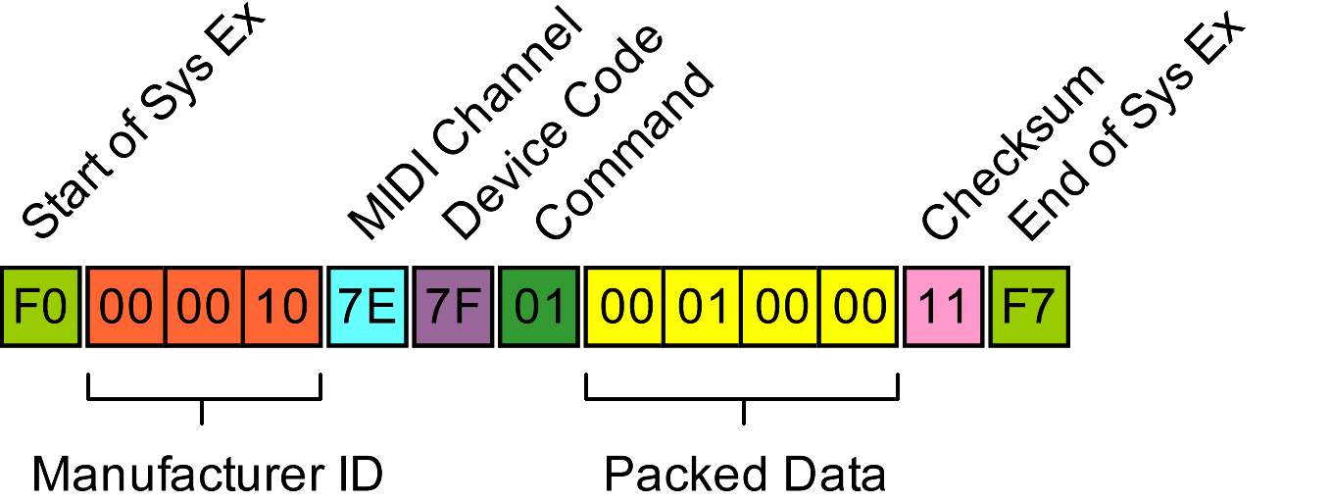
GNX1 responds with device code and MIDI channel.
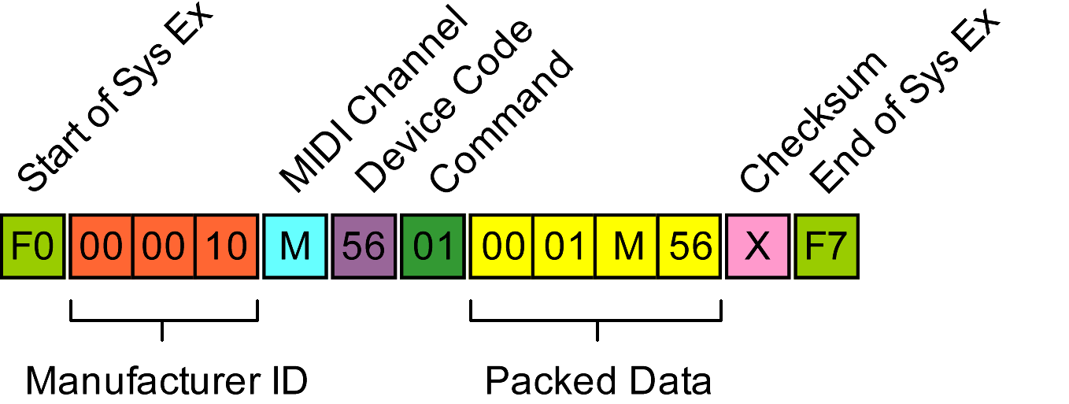
The device MIDI channel is repeated in the M data byte followed by the device code (0x56).
Note that none of the trailing 3 data bytes will be larger than 0x7F so the first data byte will always be zero. The next three data bytes are unchanged when unpacked.

Code 02: Power On Announcement
The following message is transmitted by the GNX1 when powered on, or in response to code 01 device enquiry:
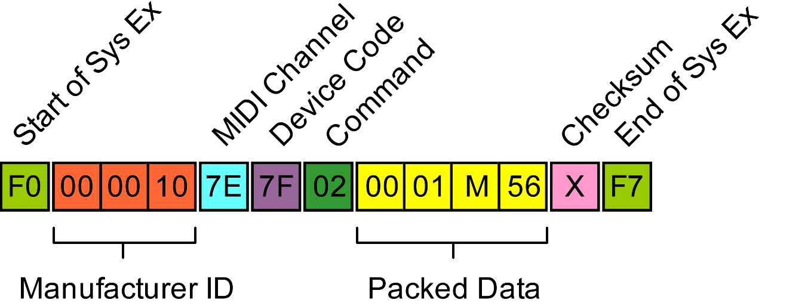
The device MIDI channel is contained in the M data byte followed by the device code (0x56).

Code 05: Status Request
Response is a code 06 message
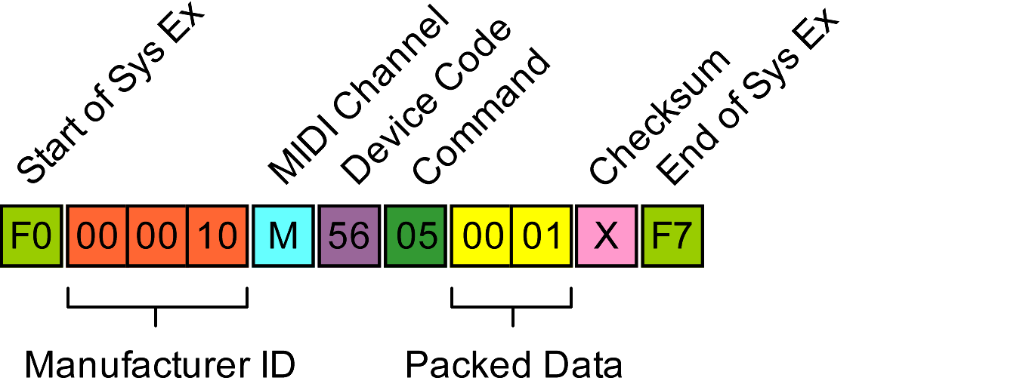

Code 06: Response to Code 05 Status Request
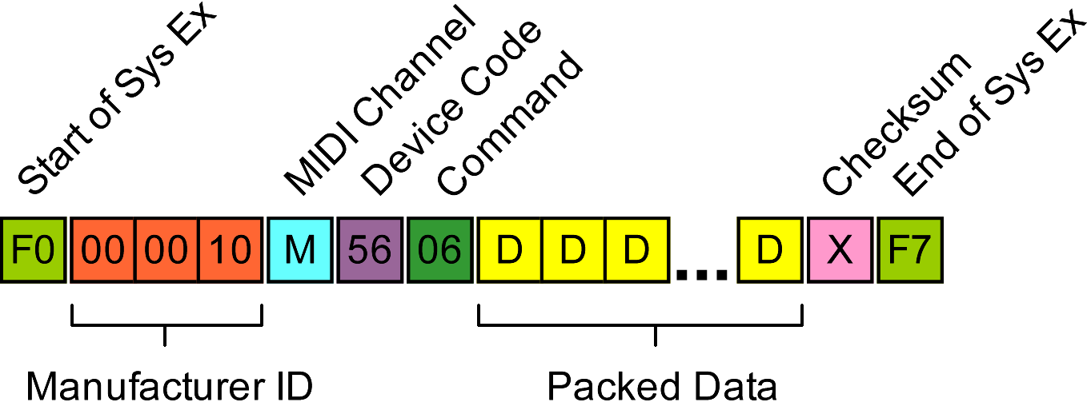
Typical response (packed data):
01 00 6F 00 15 00 25 30 . . o . . . % 0
30 03 01 06 01 01 02 01 0 . . . . . . .
05 01 06 01 07 01 08 02 . . . . . . . .
09 01 0A 02 0B 01 0C 01 . . . . . . . .
0D 01 0E 01 0F 01 10 01 . . . . . . . .
11 01 12 01 13 01 14 01 . . . . . . . .
15 01 20 01 21 01 22 01 . . . ! . " .
23 01 24 02 25 01 26 02 # . $ . % . & .
27 01 28 01 29 01 2A 01 ' . ( . ) . * .
2B 01 2C 02 2D 01 2E 01 + . , . - . . .
70 01 71 01 72 01 73 01 p . q . r . s .
74 01 75 01 76 01 7E 01 t . u . v . ~ .
7F 01

: Current Bank (00: Factory, 01: User)
: Current Patch Number (0x00 – 0x3F)
: Permitted Command Code

Following bank and patch there is an index of what appear to be accepted command codes ( ) followed by 0x01 or 0x02. Note absence of codes 0x03 – 0x04, 0x16 – 0x1F.

Code 07: Request Amp & Cab Data
Request amp and cab names
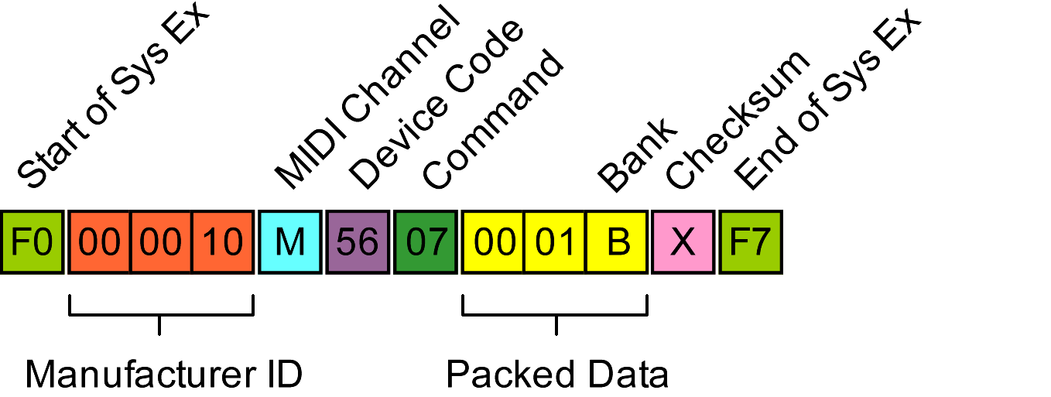
Bank is 0x00 for factory amp and cab names or 0x01 for user patches

Code 08: Response to Code 07 Request Amp and Cab Data
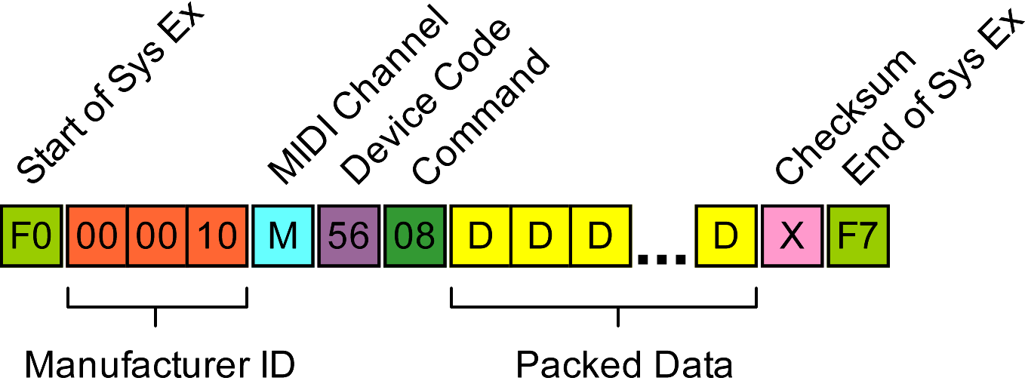
Response is an indexed list of amp and cab names. Each list is prefixed with a type code: 0x3C for amp names, 0x3D for cab names followed by a number indicating the start of the user list, then the number of names that follow. The GNX1 transmits 17 (decimal) factory amp names followed by 9 cab names. The user set depends on the number of amps saved in the user slots, and may be zero.
An example response follows:

Example Response to code 07 request for Amp and Cab Names (factory, unpacked):
02 00 02 3C 11 11 00 44 . . . < . . . D
49 52 45 43 54 00 01 42 I R E C T . . B
4C 4B 46 41 43 00 02 42 L K F A C . . B
Amp Names
KEY

: 00 = Factory, 01 = User
: 3C = Amps, 3D = Cabs
: Offset to User Names
: Number of items
: Index No.
: ASCII Name
: String terminator (null)

4F 55 54 49 51 00 03 52 O U T I Q . . R
45 43 54 49 46 00 04 48 E C T I F . . H
4F 54 52 4F 44 00 05 54 O T R O D . . T
57 45 45 44 20 00 06 42 W E E D . . B
52 54 43 4D 42 00 07 43 R T C M B . . C
4C 4E 54 55 42 00 08 42 L N T U B . . B
52 54 53 54 4B 00 09 43 R T S T K . . C
52 55 4E 43 48 00 0A 48 R U N C H . . H
49 47 41 49 4E 00 0B 42 I G A I N . . B
4C 55 45 53 20 00 0C 4D L U E S . . M
4F 44 47 41 4E 00 0D 46 O D G A N . . F
55 5A 5A 20 20 00 0E 42 U Z Z . . B
41 53 53 4D 4E 00 0F 48 A S S M N . . H
49 57 41 54 47 00 10 41 I W A T G . . A
43 4F 55 53 54 00 3D 09 C O U S T . = .
09 00 44 49 52 45 43 54 . . D I R E C T
00 01 41 4D 32 58 31 32 . . A M 2 X 1 2
Cab Names
00 02 42 52 34 58 31 32 . . B R 4 X 1 2
00 03 56 20 34 58 31 32 . . V 4 X 1 2
00 04 42 52 32 58 31 32 . . B R 2 X 1 2
00 05 41 4D 31 58 31 32 . . A M 1 X 1 2
00 06 42 4C 32 58 31 32 . . B L 2 X 1 2
00 07 46 4E 34 58 31 32 . . F N 4 X 1 2
00 08 47 52 34 58 31 32 . . G R 4 X 1 2
00 .

Code 09: Request User Bank Names
The GNX1 divides groups the user patches into 16 groups of 3 and an editable name is assigned to each of these banks. Command code 09 is used to request these names.
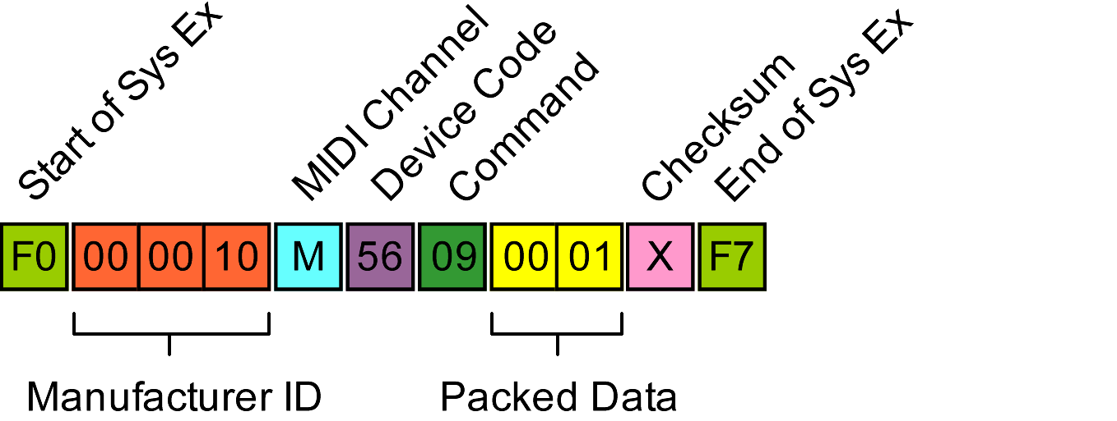

Code 0A: Response to Code 09 Request User Bank Names
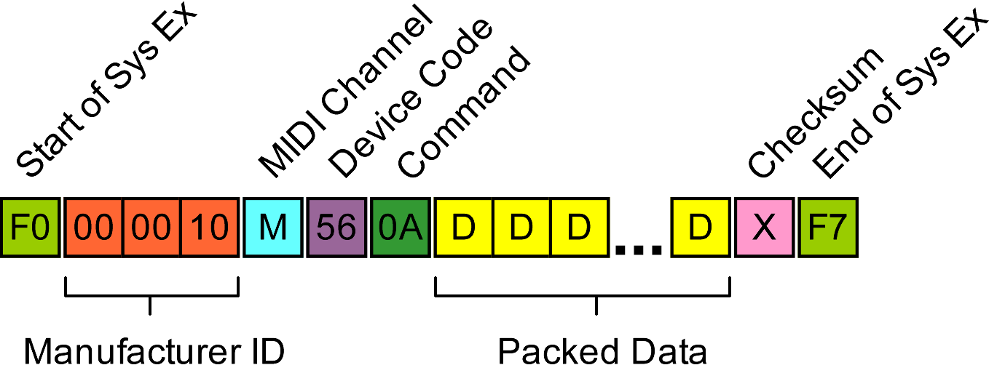
Names are returned as a set of null terminated ASCII strings followed by some spurious data.
Example response follows:
Example response:
02 03 00 04 01 10 00 F0 . . . . . . . .
KEY

: Volume Pedal Update:
00: OFF
01: ON
: ASCII Name
: String terminator (null)
: 00 = Mono, 01 = Stereo
: Target Output:
00: Direct
01: IN 1 X 12
02: FX 1 X 12
03: IN 2 X 12
04: FX 2 X 12
05: IN 4 X 12
06: FX 4 X 12
: MIDI Channel 00 – 0F
: MIDI Merge:
00: OFF
01: ON

53 48 4F 43 41 53 00 47 S H O C A S . G
45 4E 45 54 58 00 53 54 E N E T X . S T
User
Bank
Names
Character
Set
00-1F
41 52 53 20 00 41 4D 50 A R S . A M P
53 20 20 00 42 4C 55 45 S . B L U E
53 20 00 43 4E 54 52 59 S . C N T R Y
20 00 52 4F 43 4B 20 20 . R O C K
00 43 4C 45 41 4E 20 00 . C L E A N .
4D 45 54 41 4C 20 00 53 M E T A L . S
54 55 44 49 4F 00 4A 41 T U D I O . J A
5A 5A 20 20 00 56 49 4E Z Z . V I N
54 41 47 00 46 55 4E 4B T A G . F U N K
20 20 00 48 59 42 52 49 . H Y B R I
44 00 45 58 50 52 53 4E D . E X P R S N
00 53 50 45 43 49 41 00 . S P E C I A .
01 02 01 00 02 03 00 00 . . . . . . . .
80 00 80 00 01 02 03 04 . . . . . . . .
05 06 07 08 09 0A 0B 0C . . . . . . . .
0D 0E 0F 10 11 12 13 14 . . . . . . . .
15 16 17 18 19 1A 1B 1C . . . . . . . .
1D 1E 1F 20 21 22 23 24 . . . ! " # $
25 26 27 28 29 2A 2B 2C % & ' ( ) * + ,
2D 2E 2F 30 31 32 33 34 - . / 0 1 2 3 4
35 36 37 38 39 3A 3B 3C 5 6 7 8 9 : ; <
3D 3E 3F 40 41 42 43 44 = > ? @ A B C D
45 46 47 48 49 4A 4B 4C E F G H I J K L
4D 4E 4F 50 51 52 53 54 M N O P Q R S T
55 56 57 58 59 5A 5B 5C U V W X Y Z [ \
5D 5E 5F 00 01 02 03 04 ] ^ _ . . . . .
05 06 07 08 09 0A 0B 0C . . . . . . . .
0D 0E 0F 10 11 12 13 14 . . . . . . . .
15 16 17 18 19 1A 1B 1C . . . . . . . .
1D 1E 1F . . .

Changes to VSWITCH level cause this message to be transmitted, but the value does not appear in the data blocks

Code 0B: Request User Amp and Cab Patches
The GNX1 manual says that there are 9 memory slots for storing Hypermodel amps. Mine seems to allow saving beyond the 9. Either there is extra memory available or other RAM is being overwritten.
The 0B command requests data about these locations:

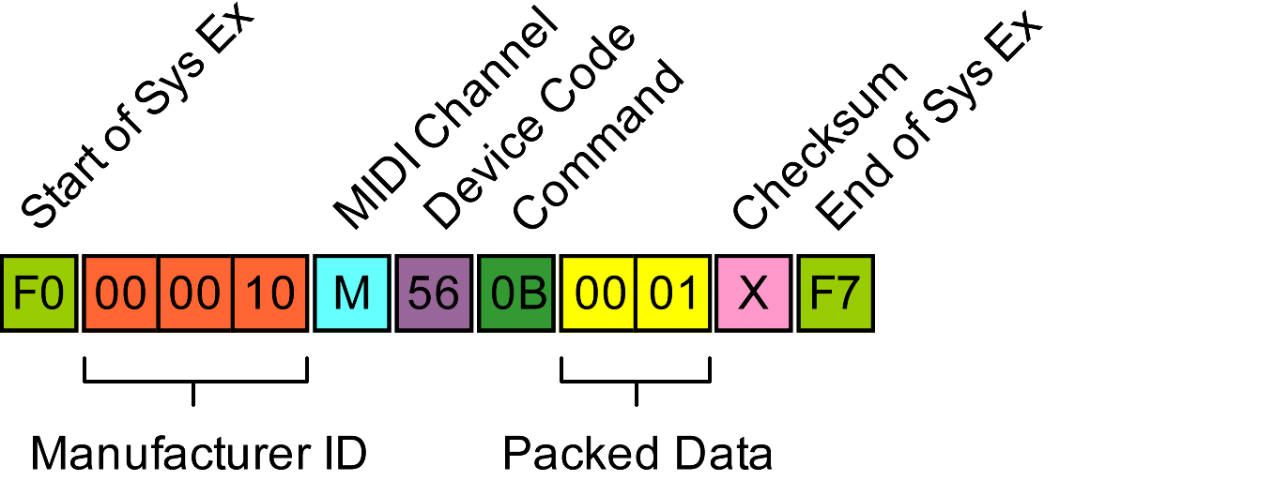
Code 0C: Unknown
Message below with parameter 0x01 returns 0x7E. Other parameters in range 0x00 to 0x0F return code 0x7F.

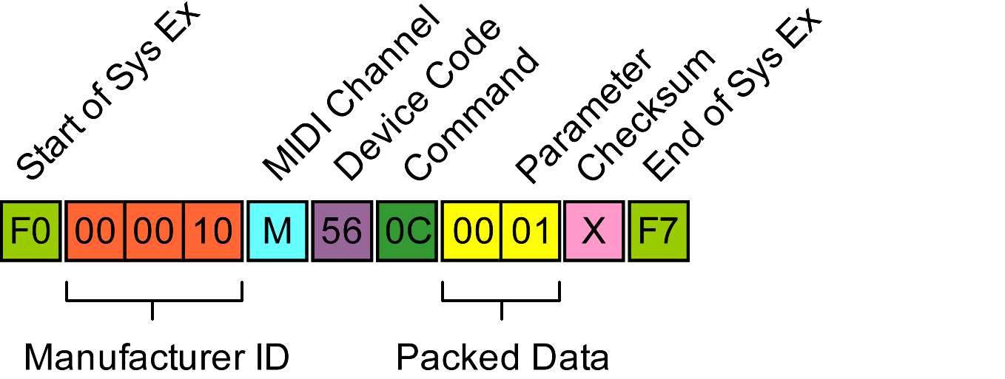
Code 0D: Unknown
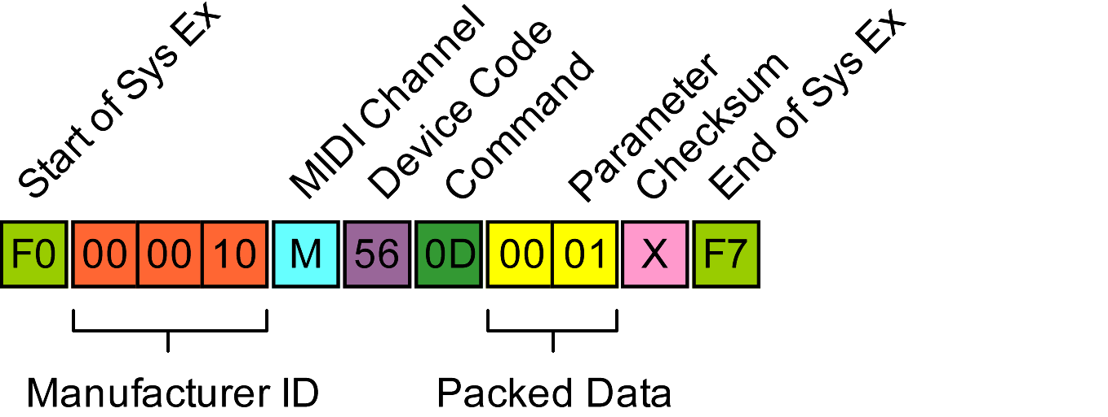
Message below with parameter 0x01 returns 0x7E. Other parameters in range 0x00 to 0x0F return code 0x7F.

Code 0E: Unknown
Message below with parameter 0x01 returns a 0xF0 message. Other parameters in range 0x00 to 0x0F return code 0x7F.
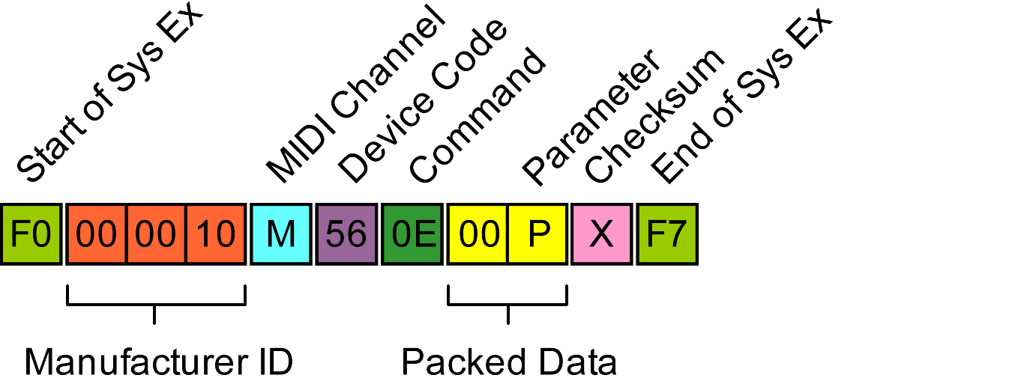
Returns unpacked 00 00 03 00 and GNX1 shows “SNDBLK” followed by “BADACK” error indicating that a bulk transfer is expected.

Code 0F: Response to Code 0B Request Amp and Cab Patches
There is an initial response, followed by blocks of patch data with a final terminating response.
Initial response:
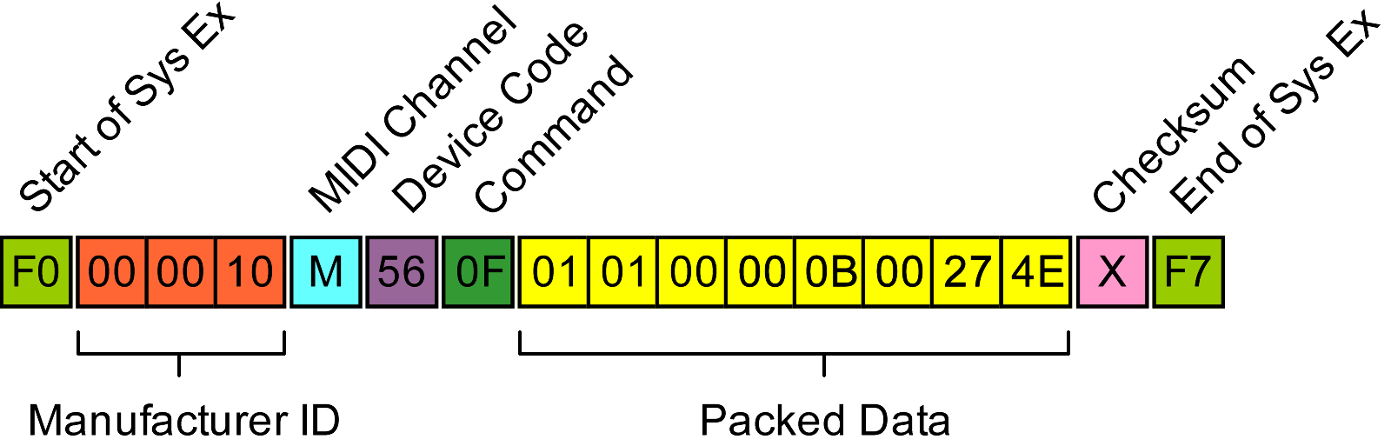
Unpacked data format is as follows:
Offset (dec) | Description
0 | Always 0x01
1 | Always 0x00
2 | Always 0x00
3 | Number of data messages that follow including terminator (minimum 0x01)
4 | Always 0x00
5 | Examples: 0x07F6 for 1 user patch, 0x0FEC for 2 patches (2x value), 0x47A6 for 9 patches. Probably an indicator of number of bytes following although exact correlation is unclear
6

Data blocks in amp/cab pairs follow, 1 pair for each occupied slot. Each data block has a 0x2A command code.

Code 10: Data Block Request Terminator
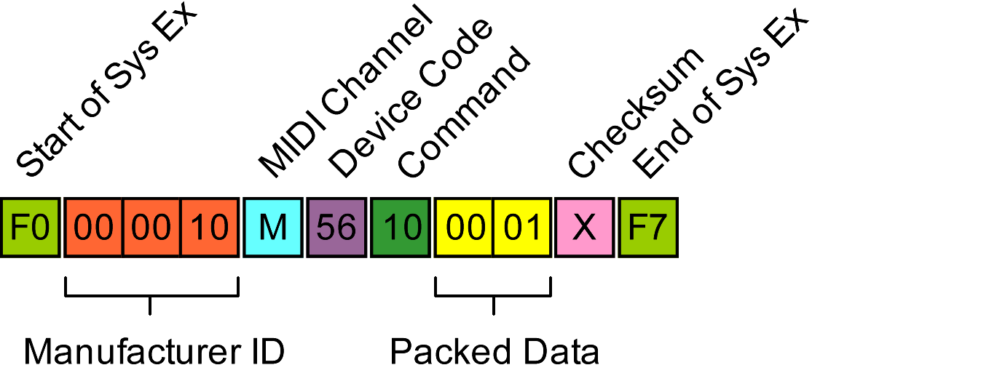
The final terminating message following data requested by a 0x0B command has a 0x10 code.

Code 11: Unknown
Message below with parameters in range 0x00 to 0x0F returns code 0x7F.
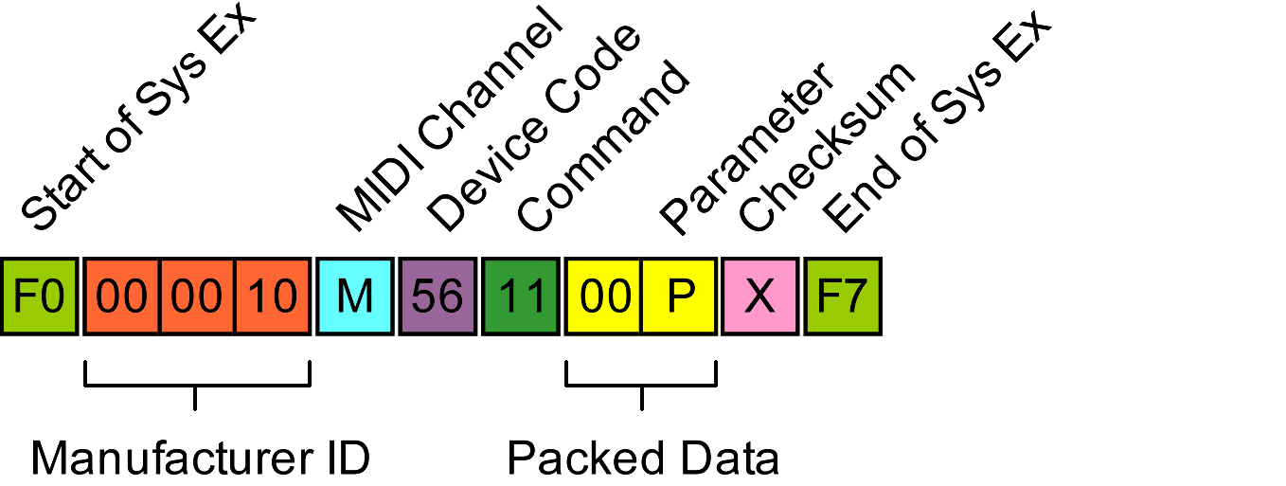

Code 12: Request Patch Names
Message below causes patch names to be transmitted. Parameter B is 0x00 for factory and 0x01 for user names.
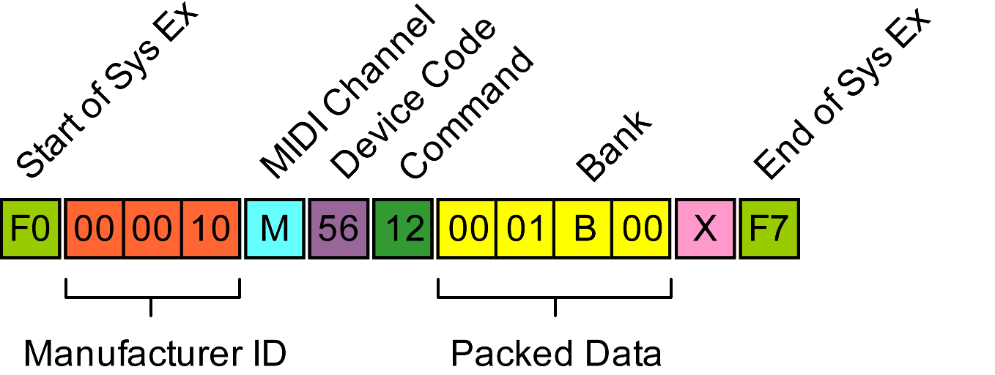

Code 13: Response to Code 12 Request Patch Names
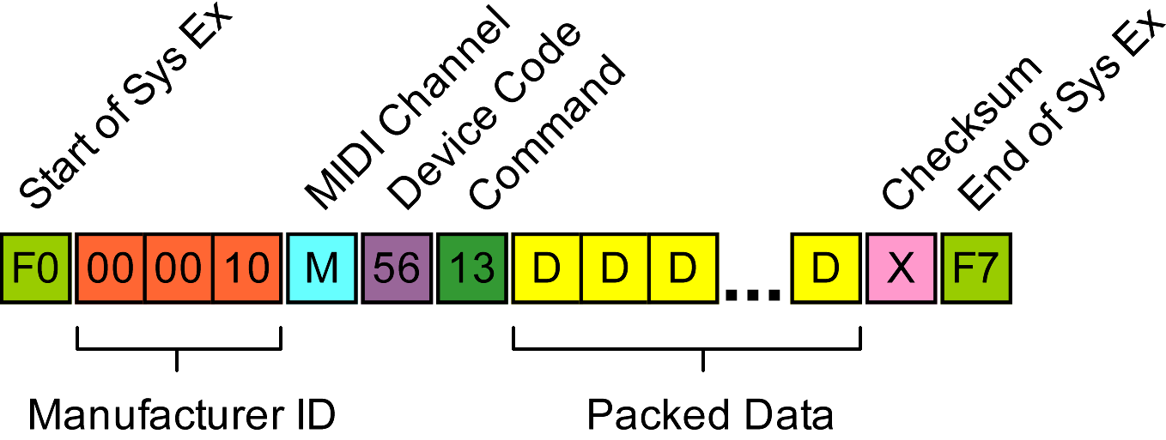
Names are returned as a set of 48 (decimal) null terminated ASCII strings. Note that the returned data does not indicate which bank it is.
Example response follows:
01 30 48 59 42 52 49 44 . 0 H Y B R I D
KEY

: Number of names
: ASCII Name
: String terminator (null)

00 43 4C 4E 43 48 4F 00 . C L N C H O .
32 43 48 55 4E 4B 00 57 2 C H U N K . W
41 52 50 4D 45 00 42 4C A R P M E . B L
4B 42 41 53 00 4D 45 41 K B A S . M E A
54 58 32 00 45 52 49 43 T X 2 . E R I C
20 4A 00 43 41 52 4C 4F J . C A R L O
....
59 41 20 20 00 53 54 55 Y A . S T U
54 54 52 00 54 52 49 50 T T R . T R I P
4C 54 00 44 49 56 42 4F L T . D I V B O
4D 00 M .

Code 14: Unknown
Message below with parameters in range 0x00 to 0x0F returns code 0x7F.
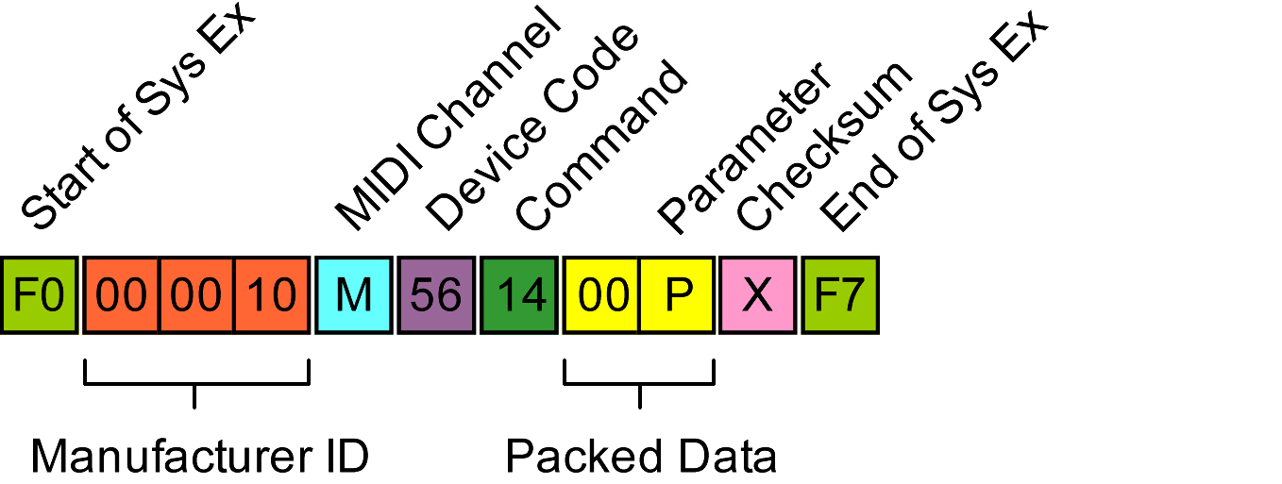

Code 15: Unknown
Message below with parameters in range 0x00 to 0x0F returns code 0x7F.
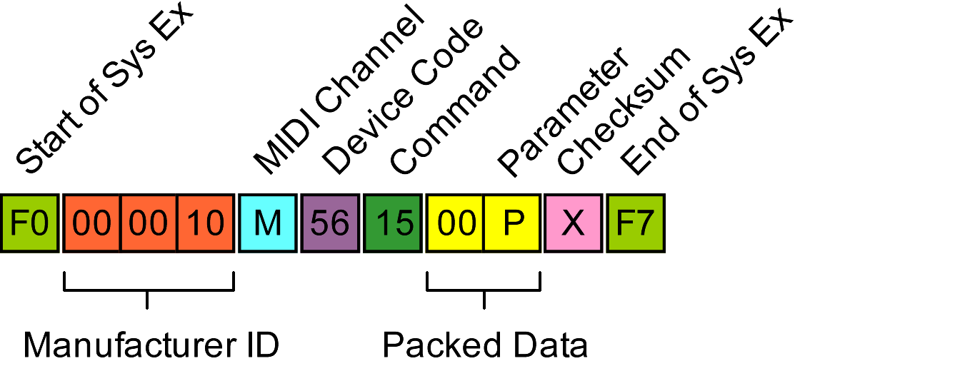

Code 20: Request Patch Name
The following requests the patch name and additional data from the specified buffer and patch. Parameter B is 0 for factory, 2 for user and 3 for edit buffer banks. Patch number is 0 – 47 (decimal), or 0 when querying the edit buffer.
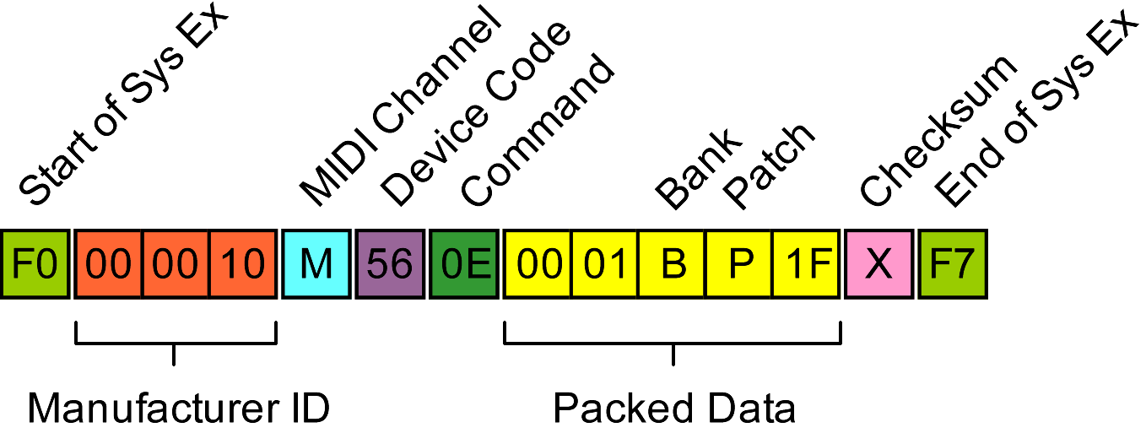

Code 21: Response to Code 20 Request Patch Name
The following is received in response to a code 20 patch name request:
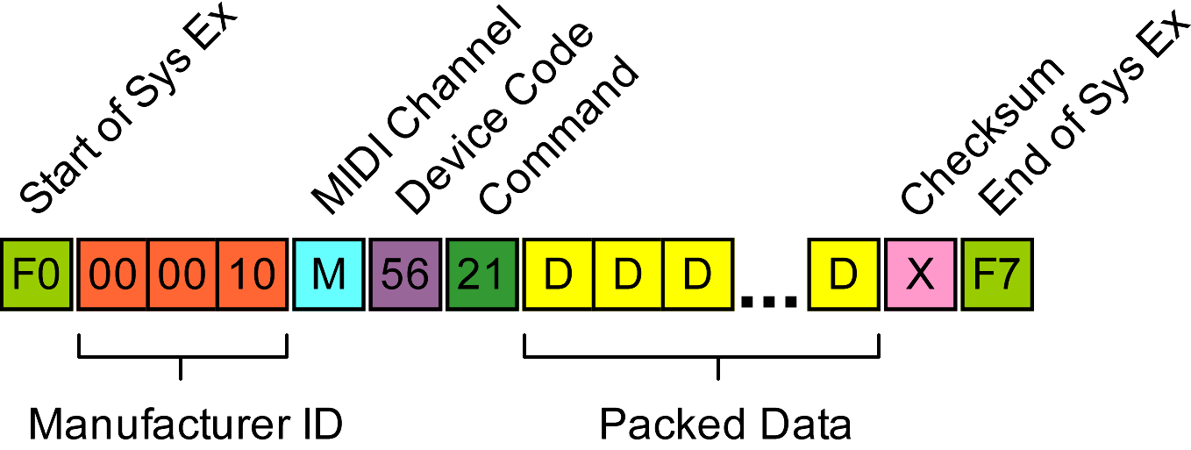
The unpacked data block is arranged as follows (edit buffer request):
01 02 00 48 59 42 52 49 . . . H Y B R I
44 00 00 08 09 A9 00 D . . . . . .

: Bank
: Patch
: ASCII Name (6 bytes)
: String terminator (null)

If unacknowledged, the GNX1 will display “BADACK” error.

Code 22: End of Data Dump
Code is transmitted by the GNX1 at the end of a multi-message data dump.
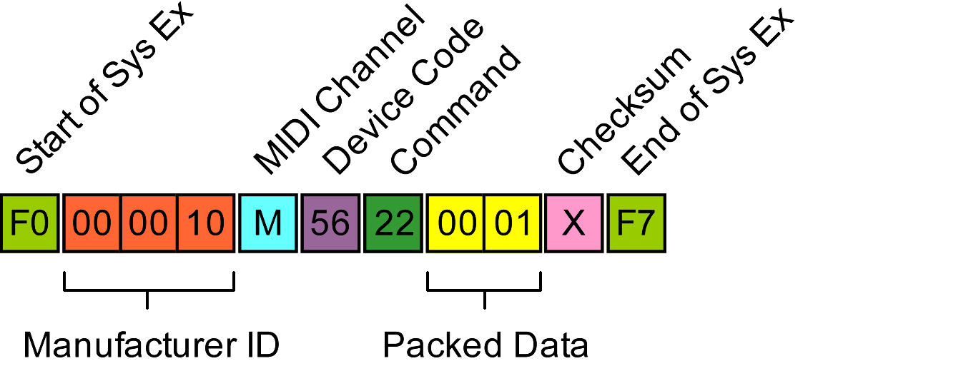

Code 23: Unknown
Message below with parameters in range 0x00 to 0x0F returns code 0x7F.

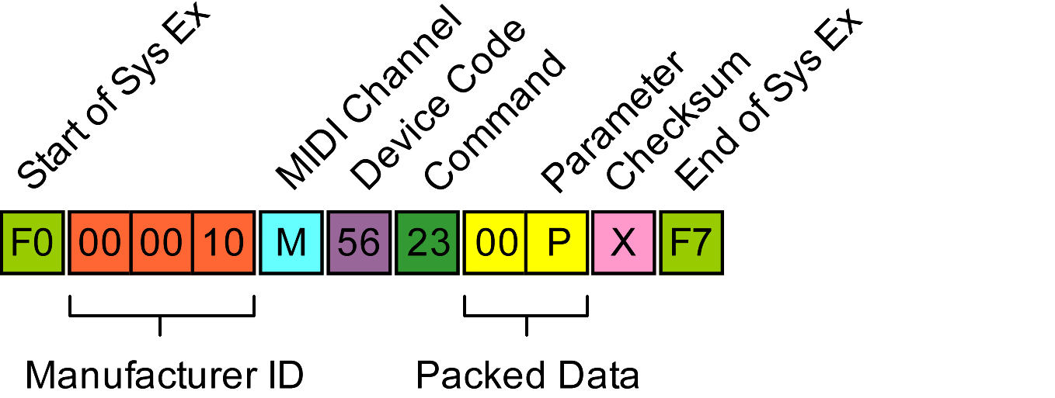
Code 24: Edit Buffer Patch Data
Patch effects data is returned in a code 24 message:
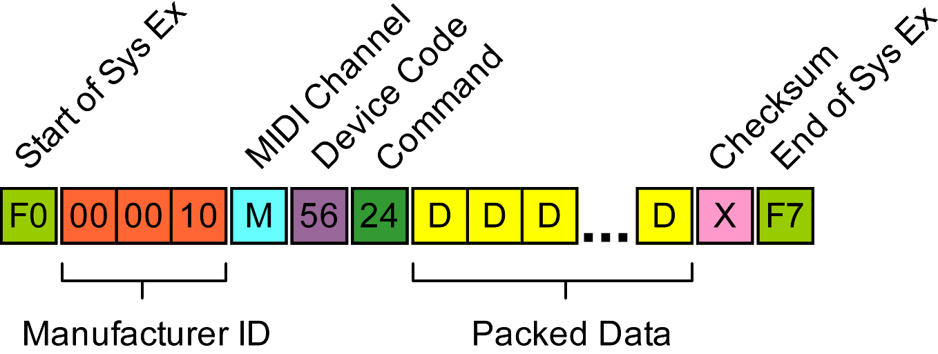
The data block contains data for effects settings where only the required number of values are included for each effect type which makes the data length for each effect section variable. Furthermore, the multi-byte number formatting described at the beginning of this document is used for effects parameter values which introduces further variability. The consequence of this is that the data block has to be analysed sequentially.
Code 24 data map:
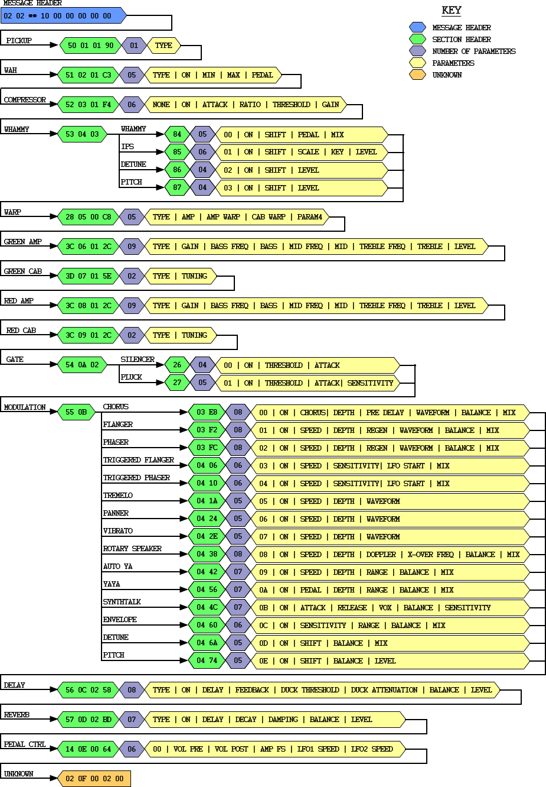

Code 25: No Response
Message below with parameters in range 0x00 to 0x0F returns no response at all.

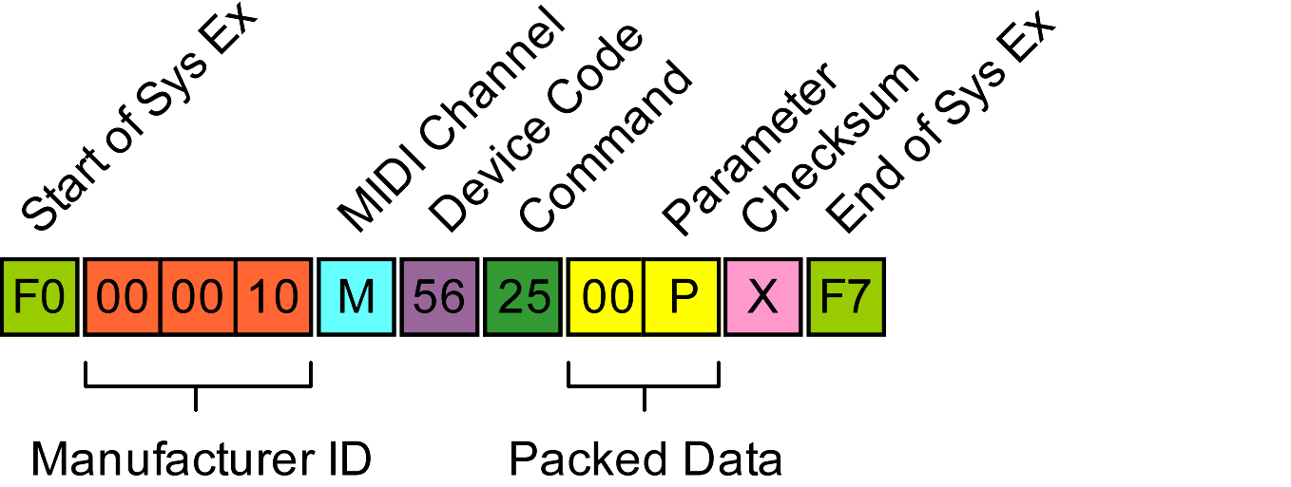
Code 26: LFO and Expression Pedals
Patch LFO and expression assignment data is returned in a code 26 message:
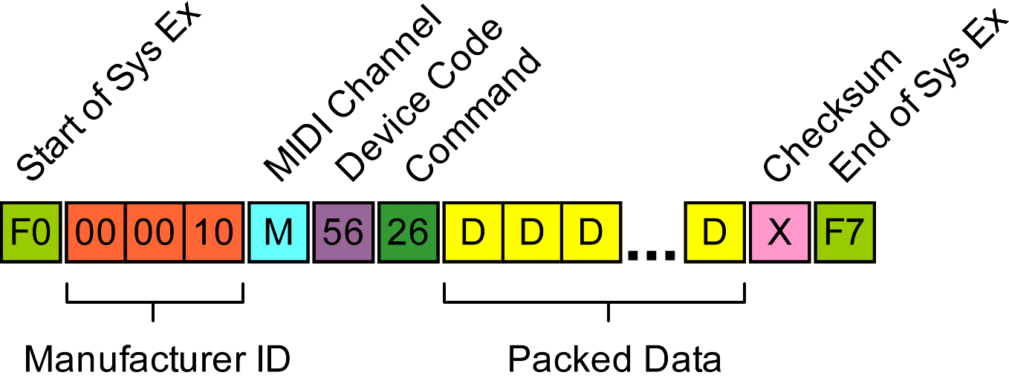
The data block contains data for effects settings where only the required number of values are included for each effect type which makes the data length for each effect section variable. Furthermore, the multi-byte number formatting described at the beginning of this document is used for effects parameter values which introduces further variability. The consequence of this is that the data block has to be analysed sequentially.
Code 26 data map:
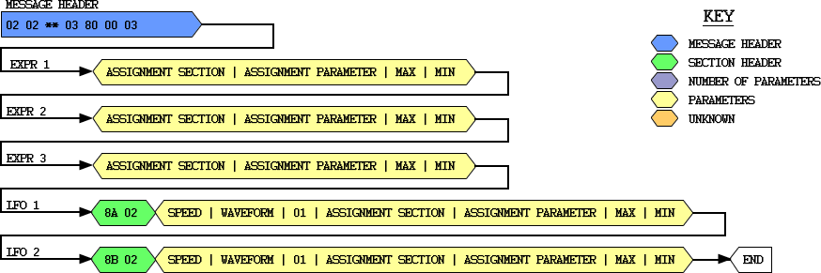
Code 26 Assignable Parameters

SECTION - PARAM | DESCRIPTION
FF FF | No Link
03 02 | Compressor Attack
03 03 | Compressor Ratio
03 04 | Compressor Threshold
03 05 | Compressor Gain
04 02 | IPS/Whammy Shift Amount
04 03 | IPS/Whammy Pedal
04 04 | IPS/Whammy Mix
05 01 | Amp Channel
05 02 | Amp Warp
05 03 | Cab Warp
05 04 | Warp
06 01 | Green Amp Gain
06 08 | Green Amp Level
08 01 | Red Amp Gain
08 08 | Red Amp Level
0A 02 | Gate Threshold
0A 03 | Gate Attack
0B 02 | Modulation Speed
0B 03 | Modulation Depth
0B 04 | Modulation Regeneration
0B 06 | Modulation Balance
0B 07 | Modulation Mix
0C 03 | Delay feedback
0C 04 | Delay Duck Threshold
0C 05 | Delay Duck Attenuation
0C 06 | Delay Balance
0C 07 | Delay Level
0D 02 | Reverb Pre Delay
0D 03 | Reverb Decay
0D 05 | Reverb Balance
0D 06 | Reverb Level
0E 01 | Vol Pre
0E 02 | Vol Post
0E 04 | LFO1 Speed
0E 05 | LFO2 Speed

Code 27: Unknown
Message below with parameters in range 0x00 to 0x0F returns code 0x7F.

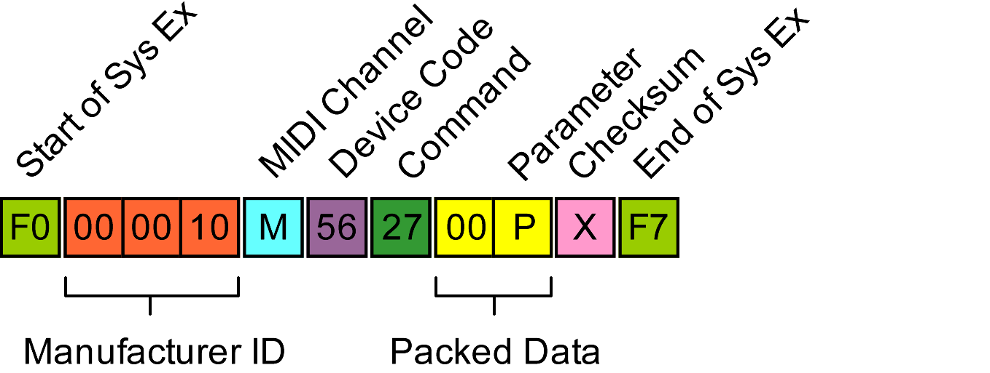
Code 28: Sync Data
A code 28 message is sent by the GNX1 when syncing with GENEdit. Values seem consistent for all patches so probably contains capability data:
01 02 00 10 00 00 00 01 . . . . . . . .
50 01 01 01 00 00 51 02 P . . . . . Q .
01 01 01 00 52 03 01 01 . . . . R . . .
02 00 53 04 01 01 03 00 . . S . . . . .
28 05 00 00 3C 06 01 01 ( . . . < . . .
04 00 3D 07 01 01 06 00 . . = . . . . .
3C 08 01 01 04 00 3D 09 < . . . . . = .
01 01 08 00 54 0A 01 01 . . . . T . . .
07 00 55 0B 01 02 0A 00 . . U . . . . .
56 0C 02 02 0B 00 0B 01 V . . . . . . .
57 0D 02 02 0C 00 0C 01 W . . . . . . .
14 0E 00 00 02 0F 02 00 . . . . . . . .
0D 00 0D 01 . . . .
: Resemble codes seen elsewhere

Code 29: Send Amp/Cab Data
Code 29 causes amp and cab data to be returned in a code 2A message
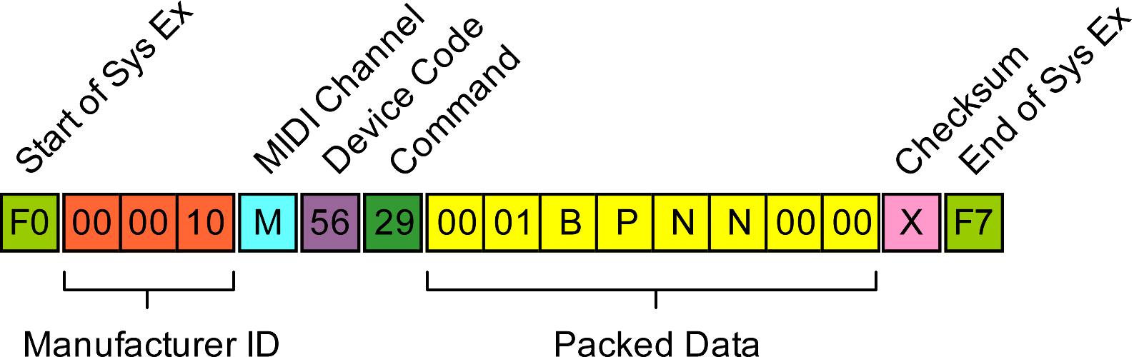
The required amp/cab is defined in the N N bytes:

N N | AMP/CAB
3C 06 | Green Amp
3D 07 | Green Cab
3C 08 | Red Amp
3D 09 | Red Cab

Code 2A: Amp or Cabinet Data Block
The code 2A is used to signify a bulk data message containing amp and cabinet data:
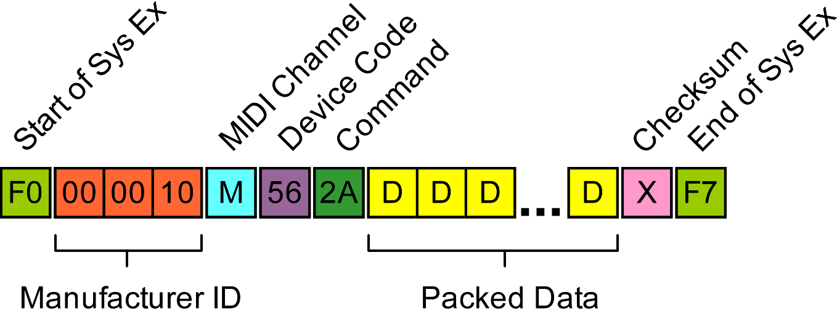
The numerical values in these data blocks are fixed 1 or 2 byte values and do not use the Number Format described at the beginning of this document. In particular, the values for equalizer frequencies consist of two bytes which can be combined to form a 16 bit integer (ms – ls order).

Code 2A data map:

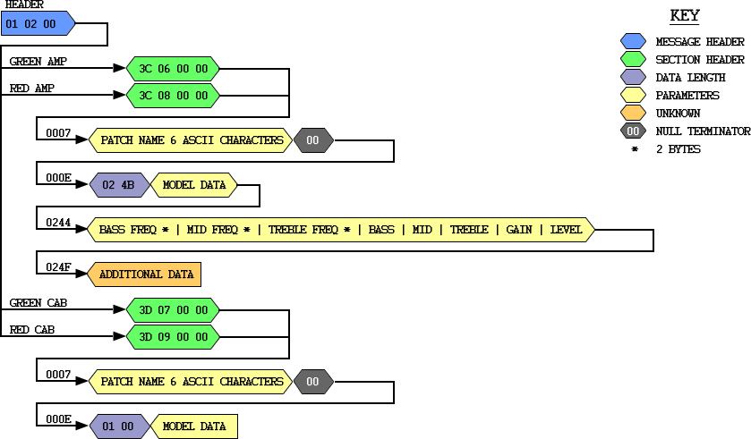
Code 2B: Unknown
Message below with parameters in range 0x00 to 0x0F returns code 0x7F.

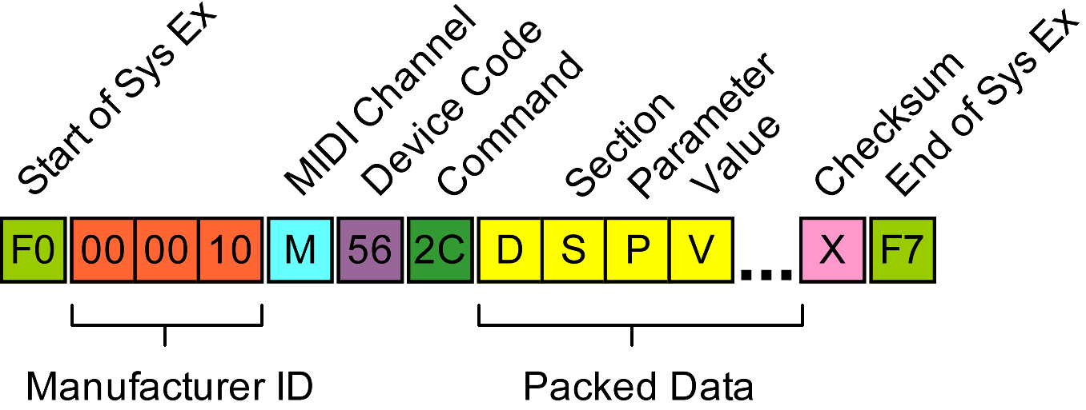
Code 2C: Parameter Change
Parameter changes are transmitted during editing with the following code:
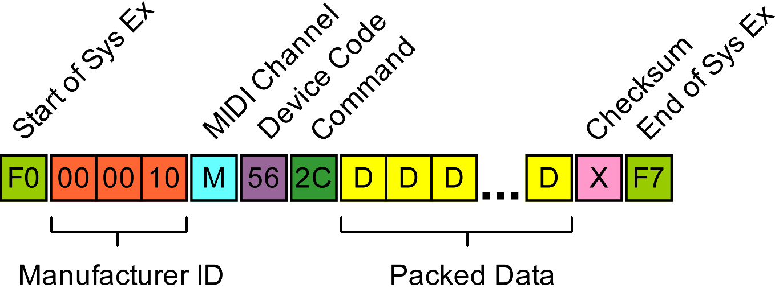
Each parameter is described by a section/parameter byte pair which are detailed below. The parameter values use the Number Format described at the beginning of this document, which will vary the overall length of the message.

Code 2C data map:

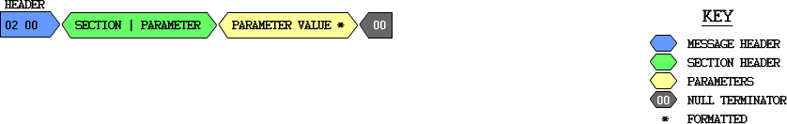
Code 2C Sections
SECTION | NAME
01 | Pickup Simulator
02 | Wah
03 | Compressor
04 | Whammy/IPS
05 | Warp
06 | Green Amp
07 | Green Cabinet
08 | Red Amp
09 | Red Cabinet
0A | Noise Gate
0B | Chorus/Mod
0C | Delay
0D | Reverb
0E | Pedal

Section 01 (Pickup Simulator) Parameters
PARAMETER | NAME | VALUES
00 | Type | 00: Off  01: Single Coil>Humb  02: Humb>Single Coil

Section 02 (Wah) Parameters
PARAMETER | NAME | VALUES
00 | Type | 00: Cry, 01: Boutique, 02: Full
01 | On/Off | 00: Off, 01: On
02 | Min | 00 – 63 (0 – 99)
03 | Max | 00 – 63 (0 – 99)
04 | Pedal | 00 – 63 (0 – 99)

Section 03 (Compressor) Parameters
PARAMETER | NAME | VALUES
00
01 | On/Off | 00: Off, 01: On
02 | Attack | 00: Fast, 01: Medium, 02: Slow
03 | Ratio | 00: 1.2:1 01: 1.5:1 02: 1.8:1 03: 2.0:1  04: 2.5:1 05: 3.0:1 06: 4.0:1 07: 5.0:1  08: 8.0:1 09: 10:1 0A: 20:1 0B: Inf
04 | Threshold | 00 – 63 (0 – 99)
05 | Gain | 00 – 14 (0 – 20)

Section 04 (Whammy/IPS) Parameters

Type 00: Whammy
PARAMETER | NAME | VALUES
00 | Type * | 00: Whammy
01 | On/Off | 00: Off, 01: On
02 | Shift | 00: 1 Oct Up 01: 2 Oct Up  02: 2nd Down 03: 2nd Dn Rev  04: 4th Down 05: 1 Oct Dn  06: 2 Oct Dn 07: Dive Bomb  08: m3>Maj3 Up 09: 2nd>Maj3 Up  0A: 3rd>4th Up 0B: 4th>5th Up  0C: 5th>Oct Up 0D: Harm Oct Up  0E: Harm Oct Dn 0F: Oct Up>Dn
03 | Pedal | 0 – 63 (0 – 99)
04 | Mix | 00 – 63 (0 – 99)

Type 01: IPS
PARAMETER | NAME | VALUES
00 | Type * | 01: IPS
01 | On/Off | 00: Off, 01: On
02 | Shift | 00: Oct Down 01: 7th Down  02: 6th Down 03: 5th Down  04: 4th Down 05: 3rd Down  06: 2nd Down 07: 2nd Up  08: 3rd Up 09: 4th Up  0A: 5th Up 0B: 6th Up  0C: 7th Up 0D: Oct Up
03 | Scale | 00: Major 01: Minor  02: Dorian 03: Mixolydian  04: Lydian 05: Harm Minor
04 | Key | 00: E 01: F 02: Gb 03: G  04: Ab 05: A 06: Bb 07: B  08: C 09: Db 0A: D 0B: Eb
05 | Level | 00 – 63 (0 – 99)

Type 02: Detune
PARAMETER | NAME | VALUES
00 | Type * | 02: Detune
01 | On/Off | 00: Off, 01: On
02 | Shift | 00 / 0C / 18 (-24 / 0 / 24) (Step 2)
03 | Level | 00 – 63 (0 – 99)

Type 03: Pitch
PARAMETER | NAME | VALUES
00 | Type * | 03: Pitch
01 | On/Off | 00: Off, 01: On
02 | Shift | 00 / 18 / 30 (-24 / 0 / 24) (Step 1)
03 | Level | 00 – 63 (0 – 99)

* Type change causes GENX1 to transmit associated parameters

Section 05 (Warp) Parameters
PARAMETER | NAME | VALUES
00
01 | Amp Select | 00: Green, 01: Red, 02: Yellow
02 | Amp | 00 – 62 (1 – 99) Green → Red
03 | Cabinet | 00 – 62 (1 – 99) Green → Red
04

Section 06 (Green Amp) Parameters
PARAMETER | NAME | VALUES
00 | Amp Type * | 00: Direct 01: Blkfac  02: Boutiq 03: Rectif  04: Hotrod 05: Tweed  06: Brtcmb 07: Clntub  08: Brtstk 09: Crunch  0A: Higain 0B: Blues  0C: Modgan 0D: Fuzz  0E: Bassmn 0F: Hiwatg  10: Acoust 11: User 1  12: User 2 13: User 3  14: User 4 15: User 5  16: User 6 17: User 7  18: User 8 19: User 9  1A: Custom
01 | Gain | 00 – 63 (0 – 99)
02 | Bass Freq | 00 – FA (50Hz – 300Hz) Step 1Hz **
03 | Bass Level | 00/0C/18 (-12/0/+12)
04 | Mid Frequency | 00 – 125C (300Hz – 5KHz) Step 1 Hz
05 | Mid Level | 00/0C/18 (-12/0/+12)
06 | Treble Freq | 00 – 1D4C (500Hz – 8KHz) Step 1Hz
07 | Treble Level | 00/0C/18 (-12/0/+12)
08 | Level | 00 – 63 (0 – 99)

* selecting amp type causes additional parameters to be transmitted
** 1 or 2 bytes (see FLAGS byte in message construct)

Section 07 (Green Cabinet) Parameters
PARAMETER | NAME | VALUES
00 | Cabinet Type * | 00: Direct 01: Am2x12  02: Br4x12 03: V 4x12  04: Br2x12 05: Am1x12  06: Bl2x12 07: Fn4x12  08: Gr4x12 09: User 1  0A: User 2 0B: User 3  0C: User 4 0D: User 5  0E: User 6 0F: User 7  10: User 8 11: User 9  12: Custom
01 | Tuning | 00/18/30 (-12/0/+12 in 0.5 steps)

Section 08 (Red Amp) Parameters
PARAMETER | NAME | VALUES
00 | Amp Type * | 00: Direct 01: Blkfac  02: Boutiq 03: Rectif  04: Hotrod 05: Tweed  06: Brtcmb 07: Clntub  08: Brtstk 09: Crunch  0A: Higain 0B: Blues  0C: Modgan 0D: Fuzz  0E: Bassmn 0F: Hiwatg  10: Acoust 11: User 1  12: User 2 13: User 3  14: User 4 15: User 5  16: User 6 17: User 7  18: User 8 19: User 9  1A: Custom
01 | Gain | 00 – 63 (0 – 99)
02 | Bass Freq | 00 – FA (50Hz – 300Hz) Step 1Hz **
03 | Bass Level | 00/0C/18 (-12/0/+12)
04 | Mid Frequency | 00 – 125C (300Hz – 5KHz) Step 1 Hz
05 | Mid Level | 00/0C/18 (-12/0/+12)
06 | Treble Freq | 00 – 1D4C (500Hz – 8KHz) Step 1Hz
07 | Treble Level | 00/0C/18 (-12/0/+12)
08 | Level | 00 – 63 (0 – 99)

* selecting amp type causes additional parameters to be transmitted
** 1 or 2 bytes (see FLAGS byte in message construct)

Section 09 (Red Cabinet) Parameters
PARAMETER | NAME | VALUES
00 | Cabinet Type * | 00: Direct 01: Am2x12  02: Br4x12 03: V 4x12  04: Br2x12 05: Am1x12  06: Bl2x12 07: Fn4x12  08: Gr4x12 09: User 1  0A: User 2 0B: User 3  0C: User 4 0D: User 5  0E: User 6 0F: User 7  10: User 8 11: User 9  12: Custom
01 | Tuning | 00/18/30 (-12/0/+12 in 0.5 steps)

Section 0A (Noise Gate) Parameters

Type 00: Silencer
PARAMETER | NAME | VALUES
00 | Type * | 00: Silencer
01 | On/Off | 00: Off, 01: On
02 | Threshold | 00 – 28 (0 – 40)
03 | Attack | 00 – 09 (0 – 9)

Type 01: Pluck
PARAMETER | NAME | VALUES
00 | Type * | 01: Pluck
01 | On/Off | 00: Off, 01: On
02 | Threshold | 00 – 28 (0 – 40)
03 | Attack | 00 – 09 (0 – 9)
04 | Sensitivity | 00 – 63 (0 – 99)

* Type change causes GENX1 to transmit associated parameters

Section 0B (Chorus/Mod) Parameters

Type 00: Chorus
PARAMETER | NAME | VALUES
00 | Type * | 00: Chorus
01 | On/Off | 00: Off, 01: On
02 | Chorus | 00 – 62 (1 – 99)
03 | Depth | 00 – 62 (1 – 99)
04 | Pre Delay | 00 – 13 (1 – 20)
05 | Waveform | 00: Triangle, 01: Sine, 02: Square
06 | Balance | 00 – 63 – C6 (-99 – 0 – 99) **
07 | Mix | 00 – 63 (0 – 99)

Type 01: Flanger
PARAMETER | NAME | VALUES
00 | Type * | 01: Flanger
01 | On/Off | 00: Off, 01: On
02 | Speed | 00 – 62 (1 – 99)
03 | Depth | 00 – 62 (1 – 99)
04 | Regen | 00 – 63 (0 – 99)
05 | Waveform | 00: Triangle, 01: Sine, 02: Square
06 | Balance | 00 – 63 – C6 (-99 – 0 – 99) **
07 | Mix | 00 – 63 (0 – 99)

Type 02: Phaser
PARAMETER | NAME | VALUES
00 | Type * | 02: Phaser
01 | On/Off | 00: Off, 01: On
02 | Speed | 00 – 62 (1 – 99)
03 | Depth | 00 – 62 (1 – 99)
04 | Regen | 00 – 63 (0 – 99)
05 | Waveform | 00: Triangle, 01: Sine, 02: Square
06 | Balance | 00 – 63 – C6 (-99 – 0 – 99) **
07 | Mix | 00 – 63 (0 – 99)

Type 03: Triggered Flanger
PARAMETER | NAME | VALUES
00 | Type * | 03: Triggered Flanger
01 | On/Off | 00: Off, 01: On
02 | Speed | 00 – 62 (1 – 99)
03 | Sensitivity | 00 – 62 (1 – 99)
04 | LFO Start | 00 – 63 (0 – 99)
05 | Mix | 00 – 63 (0 – 99)

Type 04: Triggered Phaser
PARAMETER | NAME | VALUES
00 | Type * | 04: Triggered Phaser
01 | On/Off | 00: Off, 01: On
02 | Speed | 00 – 62 (1 – 99)
03 | Sensitivity | 00 – 62 (1 – 99)
04 | LFO Start | 00 – 63 (0 – 99)
05 | Mix | 00 – 63 (0 – 99)

Type 05: Tremelo
PARAMETER | NAME | VALUES
00 | Type * | 05: Tremelo
01 | On/Off | 00: Off, 01: On
02 | Speed | 00 – 62 (1 – 99)
03 | Depth | 00 – 63 (0 – 99)
04 | Waveform | 00: Triangle, 01: Sine, 02: Square

Type 06: Panner
PARAMETER | NAME | VALUES
00 | Type * | 06: Panner
01 | On/Off | 00: Off, 01: On
02 | Speed | 00 – 62 (1 – 99)
03 | Depth | 00 – 63 (0 – 99)
04 | Waveform | 00: Triangle, 01: Sine, 02: Square

Type 07: Vibrato
PARAMETER | NAME | VALUES
00 | Type * | 07: Vibrato
01 | On/Off | 00: Off, 01: On
02 | Speed | 00 – 62 (1 – 99)
03 | Depth | 00 – 62 (1 – 99)
04 | Waveform | 00: Triangle, 01: Sine, 02: Square

Type 08: Rotary Speaker
PARAMETER | NAME | VALUES
00 | Type * | 08: Rotary Speaker
01 | On/Off | 00: Off, 01: On
02 | Speed | 00 – 63 (0 – 99)
03 | Depth | 00 – 63 (0 – 99)
04 | Doppler | 00 – 63 (0 – 99)
05 | X-Over Freq | 00 – 82 (200Hz – 1.50kHz) **  Step 10Hz
06 | Balance | 00 – 63 – C6 (-99 – 0 – 99) **
07 | Mix | 00 – 63 (0 – 99)

Type 09: Auto Yah
PARAMETER | NAME | VALUES
00 | Type * | 09: Auto Yah
01 | On/Off | 00: Off, 01: On
02 | Speed | 00 – 62 (1 – 99)
03 | Depth | 00 – 62 (1 – 99)
04 | Range | 00 – 31 (0 – 50)
05 | Balance | 00 – 63 – C6 (-99 – 0 – 99) **
06 | Mix | 00 – 63 (0 – 99)

Type 0A: YaYa
PARAMETER | NAME | VALUES
00 | Type * | 0A: YaYa
01 | On/Off | 00: Off, 01: On
02 | Pedal | 00 – 63 (0 – 99)
03 | Depth | 00 – 62 (1 – 99)
04 | Range | 00 – 31 (0 – 50)
05 | Balance | 00 – 63 – C6 (-99 – 0 – 99) **
06 | Mix | 00 – 63 (0 – 99)

Type 0B: Synthtalk
PARAMETER | NAME | VALUES
00 | Type * | 0B: Synthtalk
01 | On/Off | 00: Off, 01: On
02 | Attack | 00 – 63 (0 – 99)
03 | Release | 00 – 63 (1 – 100)
04 | Vox | 00 – 63 (0 – 99)
05 | Balance | 00 – 63 – C6 (-99 – 0 – 99) **
06 | Sensitivity | 00 – 62 (1 – 99)

Type 0C: Envelope
PARAMETER | NAME | VALUES
00 | Type * | 0C: Envelope
01 | On/Off | 00: Off, 01: On
02 | Sensitivity | 00 – 62 (1 – 99)
03 | Range | 00 – 62 (1 – 99)
04 | Balance | 00 – 63 – C6 (-99 – 0 – 99) **
05 | Mix | 00 – 63 (0 – 99)

Type 0D: Detune
PARAMETER | NAME | VALUES
00 | Type * | 0D: Detune
01 | On/Off | 00: Off, 01: On
02 | Shift Amount | 00/18/30 (-24/0/+24) (Step 1)
03 | Balance | 00 – 63 – C6 (-99 – 0 – 99) **
04 | Mix | 00 – 63 (0 – 99)

Type 0E: Pitch
PARAMETER | NAME | VALUES
00 | Type * | 0E: Pitch
01 | On/Off | 00: Off, 01: On
02 | Shift Amount | 00/0C/24 (-12/0/+24) (Step 1)
03 | Balance | 00 – 63 – C6 (-99 – 0 – 99) **
04 | Level | 00 – 63 (0 – 99)

* Type change causes GENX1 to transmit associated parameters
** 1 or 2 bytes (see FLAGS byte in message construct)

Section 0C (Delay) Parameters
PARAMETER | NAME | VALUES
00 | Type * | 00: Mono 01: Ping Pong  02: Analog 03: Alg Pong
01 | On/Off | 00: Off, 01: On
02 | Delay Time | 00 – 7D0 (0ms – 2s) Step 1ms ***
03 | Feedback | 00 – 64 (0 – 99 + R-Hold)
04 | Duck Thresh | 00 – 63 (1 – 99 + Off)
05 | Duck Atten | 00 – 63 (0 – 99)
06 | Balance | 00 – 63 – C6 (-99 – 0 – 99) **
07 | Level | 00 – 63 (0 – 99)

* Type change causes GENX1 to transmit associated parameters
** 1 or 2 bytes (see FLAGS byte in message construct)
*** 1, 2 or 3 bytes (see FLAGS byte in message construct)

Section 0D (Reverb) Parameters
PARAMETER | NAME | VALUES
00 | Type * | 00: Studio 01: Room  02: Club 03: Plate  04: Hall 05: Amphitheatre  06: Church 07: Garage  08: Arena 09: Spring
01 | On/Off | 00: Off, 01: On
02 | Pre Delay | 00 – 0F (0 – 15)
03 | Decay | 00 – 62 (1 – 99)
04 | Damping | 00 – 64 (0 – 99)
05 | Balance | 00 – 63 – C6 (-99 – 0 – 99) **
06 | Level | 00 – 63 (0 – 99)

* Type change causes GENX1 to transmit associated parameters
** 1 or 2 bytes (see FLAGS byte in message construct)

Section 0E Pedal Parameters
PARAMETER | NAME | VALUES
00 | Unknown | 01: Volume Pre 02: Volume Post
01 | Value | Min – Max Expression Setting

Section 8A (LFO 1) Parameters
PARAMETER | NAME | VALUES
TBC | Speed | 00 – B9  (0.05Hz – 0.99Hz) Step 0.01Hz  (1Hz – 10Hz) Step 0.1Hz
TBC | Waveform | 00: Triangle, 01: Sine, 02: Square

Section 8B (LFO 2) Parameters
PARAMETER | NAME | VALUES
TBC | Speed | 00 – B9  (0.05Hz – 0.99Hz) Step 0.01Hz  (1Hz – 10Hz) Step 0.1Hz
TBC | Waveform | 00: Triangle, 01: Sine, 02: Square

Code 2D: Patch Change
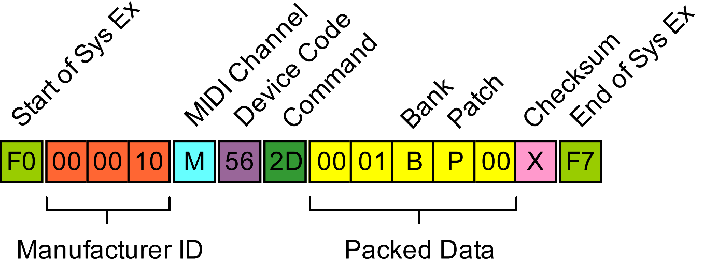
The GNX1 emits the following when a new patch is selected for editing. Parameter B is 0 for factory, 2 for user. Patch number is 0 – 47 (decimal).

Code 2E: Save Patch or Amp/Cab With Name
The the following message is used when the current edit buffer patch or amp/cab is saved to a patch or user amp/cab location with a specified name:
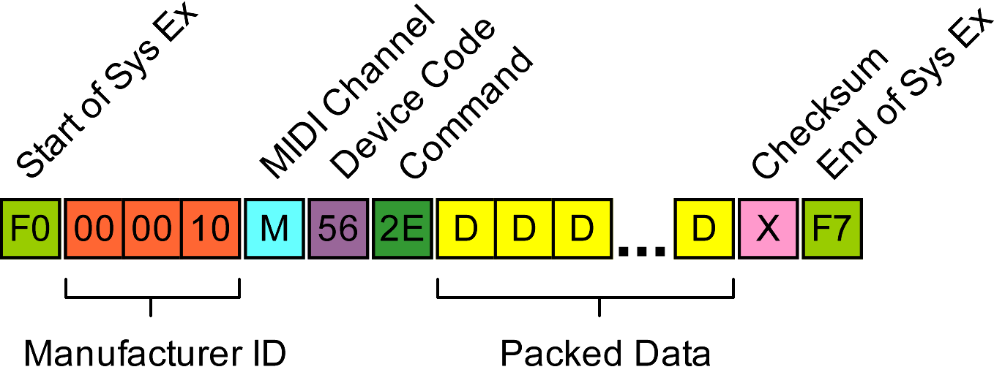
Code 2E data map:
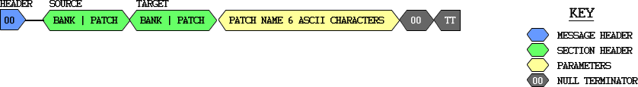
TYPE | SOURCE  BANK | SOURCE  PATCH | TARGET  BANK | TARGET  PATCH | TT
PATCH | 0x02 | 0x00 | 0x01 | PP | 0xFF
AMP/CAB 2 | 0x02 | 0x00 | 0x03 | PP | 0x00
AMP/CAB 1 | 0x02 | 0x00 | 0x04 | PP | 0x00

Banks: 0x02 = Buffer, 0x01 = User Patch, 0x03 = Amp, 0x04 = Cab

Code 76: Keep Alive
The Digitech GENEdit programs persistently sends a ‘keep alive’ command to the GNX1, which the GNX1 acknowledges commands with a code 7E command:

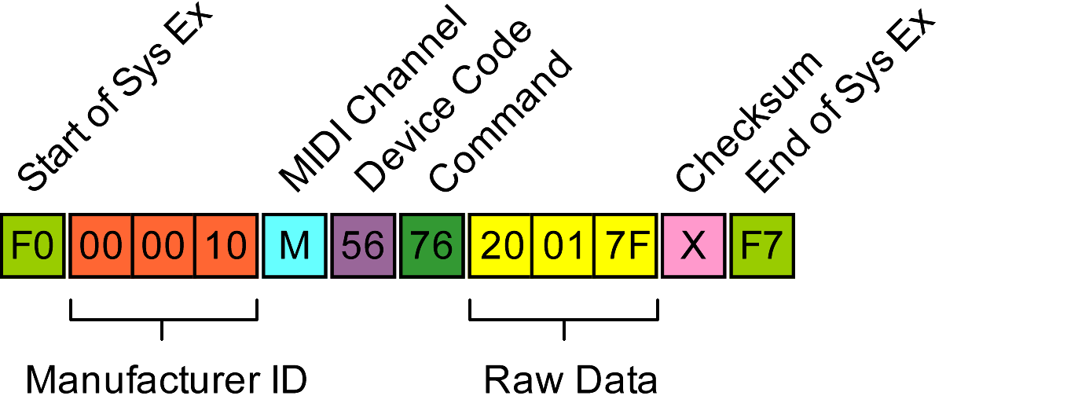
Code 7E: Acknowledge
The GNX1 acknowledges commands with a code 7E command, or notifies
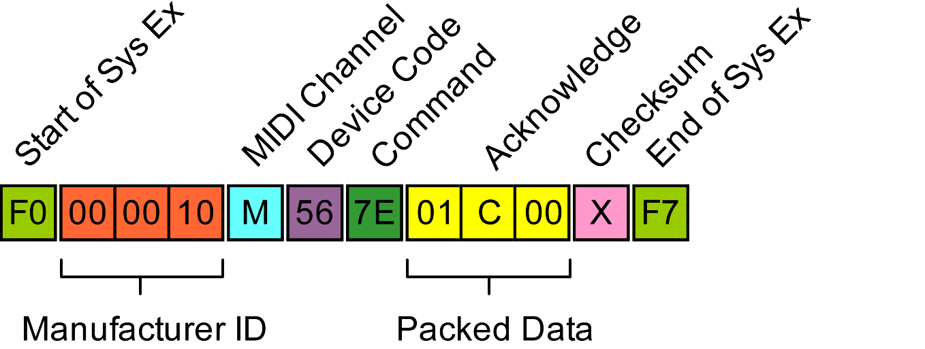

Code 7F: Error
The GNX1 reports errors (e.g.. unrecognised code, system exclusive checksum error, with a code 7F command:
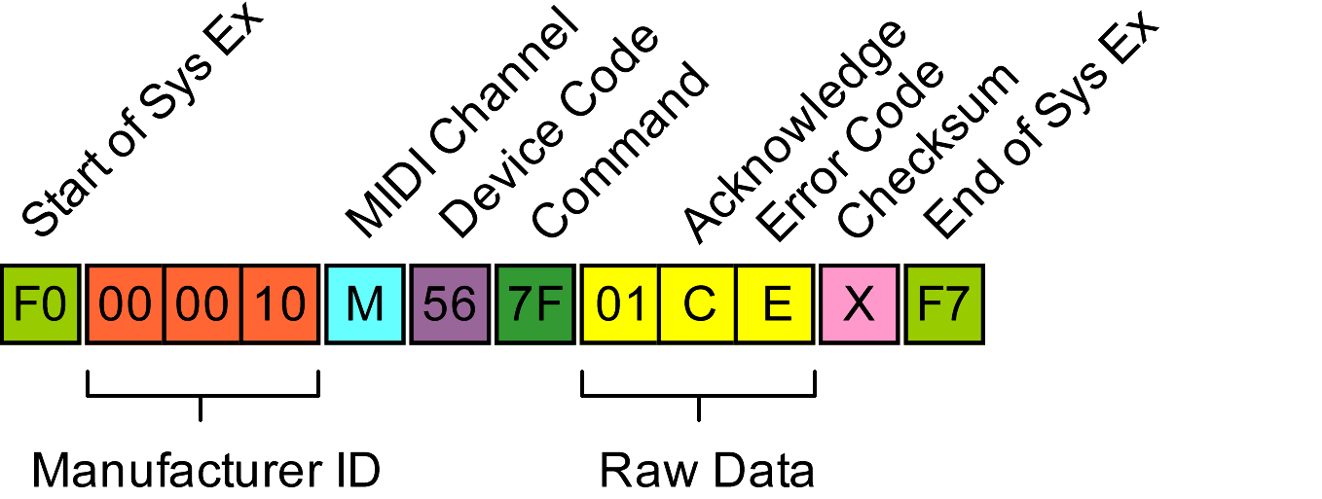
ERROR CODE | DESCRIPTION
00 | No error
01 | Unrecognised command
08 | System exclusive checksum error

GNX1 / GENEdit Startup Dialog
When the GENEdit Software establishes a link to a GNX1 device it enters a dialog to synchronise the two:


